**KARABO NICHOLAS BALOYI**

**ST10033503**

**ADDB6321**

**PRACTICUM (EXAM)**

**24 JUNE 2024**

**QUESTION 1: SET UP OF DATABASE**

CREATE TABLE INSTRUCTOR (

INS_ID VARCHAR2(10) PRIMARY KEY,

INS_FNAME VARCHAR2(50),

INS_SNAME VARCHAR2(50),

INS_CONTACT VARCHAR2(20),

INS_LEVEL NUMBER

);

INSERT INTO INSTRUCTOR (INS_ID, INS_FNAME, INS_SNAME , INS_CONTACT, INS_LEVEL)

VALUES ('101', 'James', 'Willis', '0843569851', '7');

INSERT INTO INSTRUCTOR (INS_ID, INS_FNAME, INS_SNAME , INS_CONTACT, INS_LEVEL)

VALUES ('102', 'Sam', 'Wait', '0763698521', '2');

INSERT INTO INSTRUCTOR (INS_ID, INS_FNAME, INS_SNAME , INS_CONTACT, INS_LEVEL)

VALUES ('103', 'Sally', 'Gumede', '0786598521', '8');

INSERT INTO INSTRUCTOR (INS_ID, INS_FNAME, INS_SNAME , INS_CONTACT, INS_LEVEL)

VALUES ('104', 'Bob', 'Du Preez', '0796369857', '3');

INSERT INTO INSTRUCTOR (INS_ID, INS_FNAME, INS_SNAME , INS_CONTACT, INS_LEVEL)

VALUES ('105', 'Simon', 'Jones', '0826598741', '9');

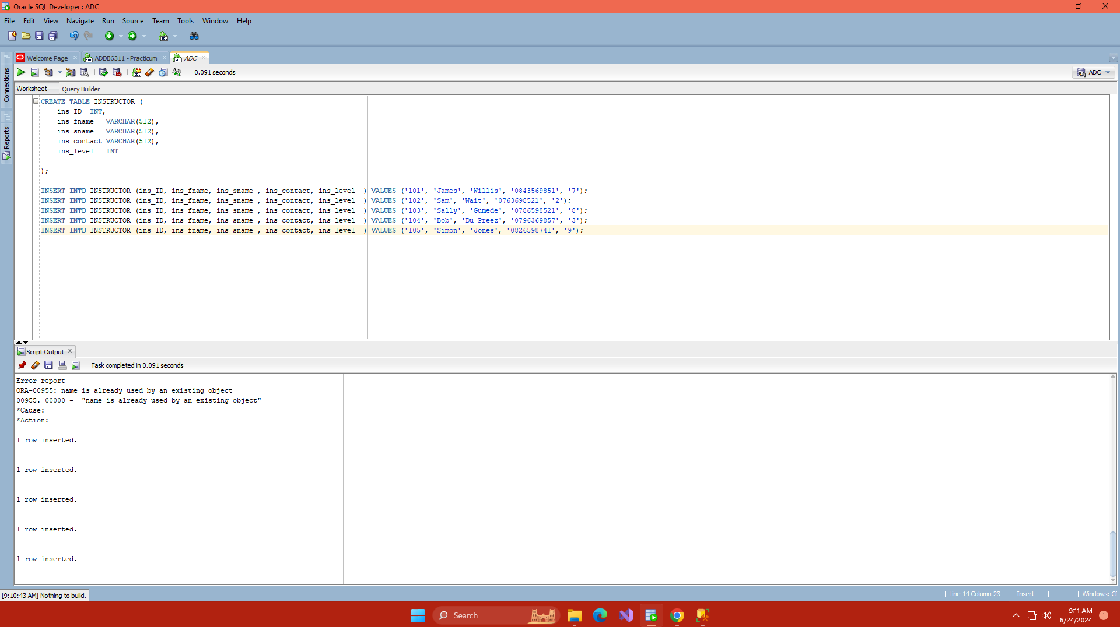

CREATE TABLE CUSTOMERS (

CUST_ID VARCHAR2(10) PRIMARY KEY,

CUST_FNAME VARCHAR2(50),

CUST_SNAME VARCHAR2(50),

CUST_ADDRESS VARCHAR2(200),

CUST_CONTACT VARCHAR2(15)

);

INSERT INTO CUSTOMERS (CUST_ID , CUST_FNAME , CUST_SNAME, CUST_ADDRESS , CUST_CONTACT) VALUES ('C115', 'Heinrich', 'Willis', '3 Main Road', '0821253659');

INSERT INTO CUSTOMERS (CUST_ID , CUST_FNAME , CUST_SNAME, CUST_ADDRESS , CUST_CONTACT) VALUES ('C116', 'David', 'Watson', '13 Cape Road', '0769658547');

INSERT INTO CUSTOMERS (CUST_ID , CUST_FNAME , CUST_SNAME, CUST_ADDRESS , CUST_CONTACT) VALUES ('C117', 'Waldo', 'Smith', '3 Mountain Road', '0863256574');

INSERT INTO CUSTOMERS (CUST_ID , CUST_FNAME , CUST_SNAME, CUST_ADDRESS , CUST_CONTACT) VALUES ('C118', 'Alex', 'Hanson', '8 Circle Road', '0762356587');

INSERT INTO CUSTOMERS (CUST_ID , CUST_FNAME , CUST_SNAME, CUST_ADDRESS , CUST_CONTACT) VALUES ('C119', 'Kuhle', 'Bitterhout', '15 Main Road', '0821235258');

INSERT INTO CUSTOMERS (CUST_ID , CUST_FNAME , CUST_SNAME, CUST_ADDRESS , CUST_CONTACT) VALUES ('C120', 'Thando', 'Zolani', '88 Summer Road', '0847541254');

INSERT INTO CUSTOMERS (CUST_ID , CUST_FNAME , CUST_SNAME, CUST_ADDRESS , CUST_CONTACT) VALUES ('C121', 'Philip', 'Jackson', '3 Long Road', '0745556658');

INSERT INTO CUSTOMERS (CUST_ID , CUST_FNAME , CUST_SNAME, CUST_ADDRESS , CUST_CONTACT) VALUES ('C122', 'Sarah', 'Jones', '7 Sea Road', '0814745745');

INSERT INTO CUSTOMERS (CUST_ID , CUST_FNAME , CUST_SNAME, CUST_ADDRESS , CUST_CONTACT) VALUES ('C123', 'Catherine', 'Howard', '31 Lake Side Road', '0822232521');

(Independent Institute of Education, 2024)

CREATE TABLE DIVE (

DIVE_ID VARCHAR2(10) PRIMARY KEY,

DIVE_NAME VARCHAR2(50),

DIVE_DURATION VARCHAR2(50),

DIVE_LOCATION VARCHAR2(50),

DIVE_EXP_LEVEL NUMBER,

DIVE_COST VARCHAR2(10)

);

INSERT INTO DIVE (DIVE_ID , DIVE_NAME , DIVE_DURATION , DIVE_LOCATION , DIVE_EXP_LEVEL , DIVE_COST )

VALUES ('550', 'Shark Dive ', '3 hours ', 'Shark Point ', '8', '500');

INSERT INTO DIVE (DIVE_ID , DIVE_NAME , DIVE_DURATION , DIVE_LOCATION , DIVE_EXP_LEVEL , DIVE_COST )

VALUES ('551', 'Coral Dive ', '1 hour ', 'Break Point ', '7', '300');

INSERT INTO DIVE (DIVE_ID , DIVE_NAME , DIVE_DURATION , DIVE_LOCATION , DIVE_EXP_LEVEL , DIVE_COST )

VALUES ('552', 'Wave Crescent', '2 hours ', 'Ship wreck ally ', '3', '800');

INSERT INTO DIVE (DIVE_ID , DIVE_NAME , DIVE_DURATION , DIVE_LOCATION , DIVE_EXP_LEVEL , DIVE_COST )

VALUES ('553', 'Underwater Exploration', '1 hour ', 'Coral ally ', '2', '250');

INSERT INTO DIVE (DIVE_ID , DIVE_NAME , DIVE_DURATION , DIVE_LOCATION , DIVE_EXP_LEVEL , DIVE_COST )

VALUES ('554', 'Underwater Adventure', '3 hours ', 'Sandy Beach ', '3', '750');

INSERT INTO DIVE (DIVE_ID , DIVE_NAME , DIVE_DURATION , DIVE_LOCATION , DIVE_EXP_LEVEL , DIVE_COST )

VALUES ('555', 'Deep Blue Ocean', '30 minutes ', 'Lazy Waves ', '2', '120');

INSERT INTO DIVE (DIVE_ID , DIVE_NAME , DIVE_DURATION , DIVE_LOCATION , DIVE_EXP_LEVEL , DIVE_COST )

VALUES ('556', 'Rough Seas ', '1 hour ', 'Pipe ', '9', '700');

INSERT INTO DIVE (DIVE_ID , DIVE_NAME , DIVE_DURATION , DIVE_LOCATION , DIVE_EXP_LEVEL , DIVE_COST )

VALUES ('557', 'White Water ', '2 hours ', 'Drifts ', '5', '200');

INSERT INTO DIVE (DIVE_ID , DIVE_NAME , DIVE_DURATION , DIVE_LOCATION , DIVE_EXP_LEVEL , DIVE_COST )

VALUES ('558', 'Current Adventure', '2 hours ', 'Rock Lands ', '3', '150');

CREATE TABLE DIVE_EVENT (

DIVE_EVENT_ID VARCHAR2(10),

DIVE_DATE DATE,

DIVE_PARTICIPANTS NUMBER,

INS_ID VARCHAR2(10),

CUST_ID VARCHAR2(10),

DIVE_ID VARCHAR2(10),

FOREIGN KEY (INS_ID) REFERENCES INSTRUCTOR(INS_ID),

FOREIGN KEY (CUST_ID) REFERENCES CUSTOMERS(CUST_ID),

FOREIGN KEY (DIVE_ID) REFERENCES DIVE(DIVE_ID)

);

INSERT INTO DIVE_EVENT (DIVE_EVENT_ID , DIVE_DATE, DIVE_PARTICIPANTS , INS_ID , CUST_ID , DIVE_ID) VALUES ('de_101', '15-Jul-17', '5', '103', 'C115', '558');

INSERT INTO DIVE_EVENT (DIVE_EVENT_ID , DIVE_DATE, DIVE_PARTICIPANTS , INS_ID , CUST_ID , DIVE_ID) VALUES ('de_102', '16-Jul-17', '7', '102', 'C117', '555');

INSERT INTO DIVE_EVENT (DIVE_EVENT_ID , DIVE_DATE, DIVE_PARTICIPANTS , INS_ID , CUST_ID , DIVE_ID) VALUES ('de_103', '18-Jul-17', '8', '104', 'C118', '552');

INSERT INTO DIVE_EVENT (DIVE_EVENT_ID , DIVE_DATE, DIVE_PARTICIPANTS , INS_ID , CUST_ID , DIVE_ID) VALUES ('de_104', '19-Jul-17', '3', '101', 'C119', '551');

INSERT INTO DIVE_EVENT (DIVE_EVENT_ID , DIVE_DATE, DIVE_PARTICIPANTS , INS_ID , CUST_ID , DIVE_ID) VALUES ('de_105', '21-Jul-17', '5', '104', 'C121', '558');

INSERT INTO DIVE_EVENT (DIVE_EVENT_ID , DIVE_DATE, DIVE_PARTICIPANTS , INS_ID , CUST_ID , DIVE_ID) VALUES ('de_106', '22-Jul-17', '8', '105', 'C120', '556');

INSERT INTO DIVE_EVENT (DIVE_EVENT_ID , DIVE_DATE, DIVE_PARTICIPANTS , INS_ID , CUST_ID , DIVE_ID) VALUES ('de_107', '25-Jul-17', '10', '105', 'C115', '554');

INSERT INTO DIVE_EVENT (DIVE_EVENT_ID , DIVE_DATE, DIVE_PARTICIPANTS , INS_ID , CUST_ID , DIVE_ID) VALUES ('de_108', '27-Jul-17', '5', '101', 'C122', '552');

INSERT INTO DIVE_EVENT (DIVE_EVENT_ID , DIVE_DATE, DIVE_PARTICIPANTS , INS_ID , CUST_ID , DIVE_ID) VALUES ('de_109', '28-Jul-17', '3', '102', 'C123', '553');

**QUESTION 3**

SELECT

I.INS_FNAME || ' ' || I.INS_SNAME AS INSTRUCTOR_NAME,

C.CUST_FNAME || ' ' || C.CUST_SNAME AS CUSTOMER_NAME,

D.DIVE_LOCATION,

DE.DIVE_PARTICIPANTS

FROM DIVE_EVENT DE

JOIN

INSTRUCTOR I ON DE.INS_ID = I.INS_ID

JOIN

CUSTOMERS C ON DE.CUST_ID = C.CUST_ID

JOIN

DIVE D ON DE.DIVE_ID = D.DIVE_ID

WHERE

DE.DIVE_PARTICIPANTS BETWEEN 8 AND 10;

(Independent Institute of Education, 2024)

**QUESTION 4**

SET SERVEROUTPUT ON;

DECLARE

CURSOR dive_cursor IS

SELECT

D.DIVE_NAME,

DE.DIVE_DATE

FROM

DIVE_EVENT DE

JOIN

DIVE D ON DE.DIVE_ID = D.DIVE_ID

WHERE

DE.DIVE_PARTICIPATIONS >=10;

dive_record dive_cursor%ROWTYPE;

BEGIN

OPEN dive_cursor;

LOOP

FETCH dive_cursor INTO dive_record;

EXIT WHEN dive_cursor%NOTFOUND;

DBMS_OUTPUT.PUT_LINE('Dive Name: ' || dive_record.DIVE_NAME || ', Allocated Date: ' || TO_CHAR(dive_record.DIVE_DATE, 'DD-Mon-YYYY'));

END LOOP;

CLOSE dive_cursor;

END;

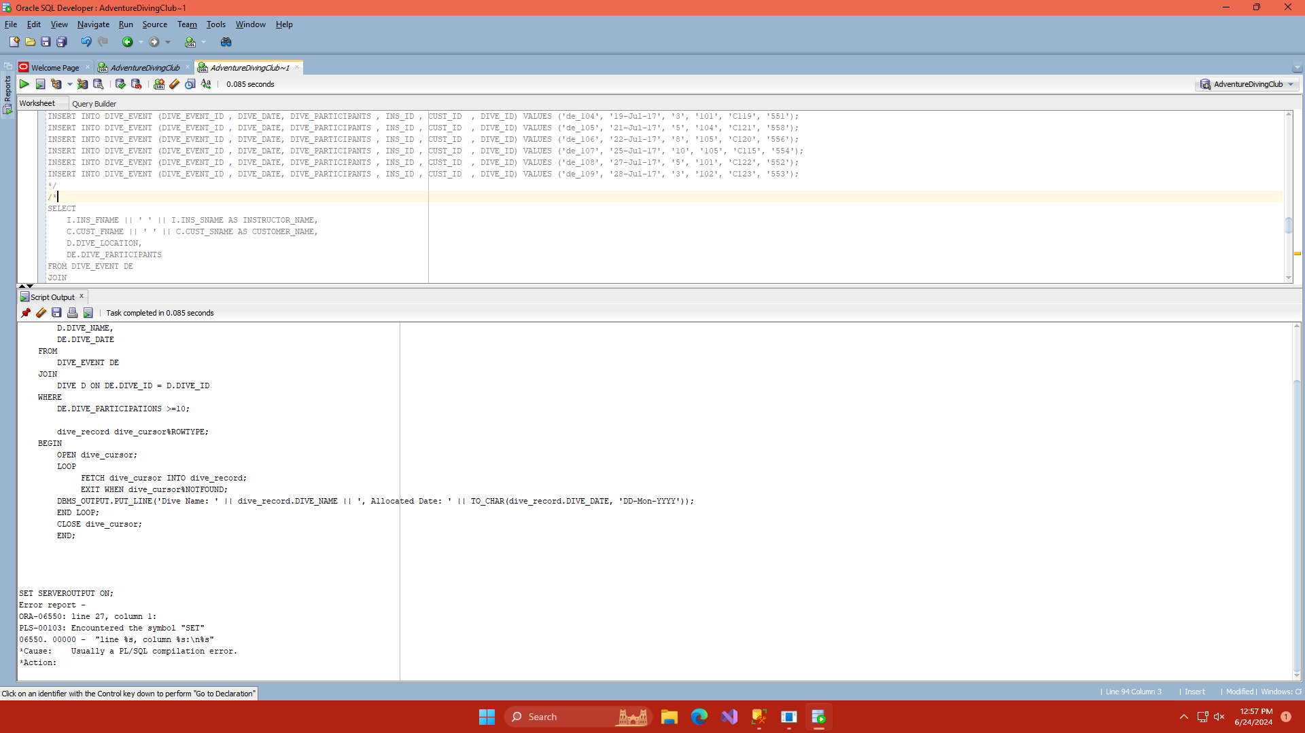

**QUESTION 5**

DECLARE

CURSOR dive_cursor IS

SELECT C.CUST_FNAME || ', ' || C.CUST_SNAME AS CUSTOMER_NAME,

D.DIVE_NAME,

DE.DIVE_PARTICIPANTS,

D.DIVE_COST

FROM DIVE_EVENT DE

JOIN CUSTOMERS C ON DE.CUST_ID = C.CUST_ID

JOIN DIVE D ON DE.DIVE_ID = D.DIVE_ID

WHERE TO_NUMBER(D.DIVE_COST) > 500;

dive_record dive_cursor%ROWTYPE;

num_instructors NUMBER;

BEGIN

-- Open the cursor

OPEN dive_cursor;

-- Loop through each record in the cursor

LOOP

FETCH dive_cursor INTO dive_record;

EXIT WHEN dive_cursor%NOTFOUND;

-- Determine the number of instructors required based on the policy

IF dive_record.DIVE_PARTICIPANTS <= 4 THEN

num_instructors := 1;

ELSIF dive_record.DIVE_PARTICIPANTS BETWEEN 5 AND 7 THEN

num_instructors := 2;

ELSE

num_instructors := 3;

END IF;

-- Display the customer name, dive name, participants, and number of instructors required

DBMS_OUTPUT.PUT_LINE('CUSTOMER: ' || dive_record.CUSTOMER_NAME);

DBMS_OUTPUT.PUT_LINE('DIVE NAME: ' || dive_record.DIVE_NAME);

DBMS_OUTPUT.PUT_LINE('PARTICIPANTS: ' || dive_record.DIVE_PARTICIPANTS);

DBMS_OUTPUT.PUT_LINE('STATUS: ' || num_instructors || ' Instructors required');

DBMS_OUTPUT.PUT_LINE('-------------------------------------------');

END LOOP;

CLOSE dive_cursor;

END;

**QUESTION 6**

CREATE OR REPLACE VIEW Vw_Dive_Event AS

SELECT

DE.INS_ID AS INSTRUCTOR_ID,

DE.CUST_ID AS CUSTOMER_ID,

C.CUST_ADDRESS AS CUSTOMER_ADDRESS,

D.DIVE_DURATION

FROM

DIVE_EVENT DE

JOIN CUSTOMERS C ON DE.CUST_ID = C.CUST_ID

JOIN DIVE D ON DE.DIVE_ID = D.DIVE_ID

WHERE

DE.DIVE_DATE < TO_DATE('19-Jul-2017', 'DD-Mon-YYYY');

**QUESTION 7**

CREATE OR REPLACE TRIGGER New_Dive_Event

BEFORE INSERT OR UPDATE ON DIVE_EVENT

FOR EACH ROW

BEGIN

IF :NEW.DIVE_PARTICIPANTS <= 0

OR :NEW.DIVE_PARTICIPANTS > 20

THEN

RAISE_APPLICATION_ERROR(-20001, 'The number of participants must be between 1 and 20');

end if;

END;

(sharper, 2017)

**QUESTION 8**

CREATE OR REPLACE PROCEDURE sp_Customer_Details (

p_CUST_ID IN CUSTOMERS.CUST_ID%TYPE,

p_DIVE_DATE IN DIVE_EVENT.DIVE_DATE%TYPE

) IS

v_CUST_FNAME CUSTOMERS.CUST_FNAME%TYPE;

v_CUST_SNAME CUSTOMERS.CUST_SNAME%TYPE;

v_DIVE_NAME DIVE.DIVE_NAME%TYPE;

BEGIN

SELECT C.CUST_FNAME, C.CUST_SNAME, D.DIVE_NAME

INTO v_CUST_FNAME, v_CUST_SNAME, v_DIVE_NAME

FROM CUSTOMERS C

JOIN DIVE_EVENT DE ON C.CUST_ID = DE.CUST_ID

JOIN DIVE D ON DE.DIVE_ID = D.DIVE_ID

WHERE C.CUST_ID = p_CUST_ID

AND DE.DIVE_DATE = p_DIVE_DATE;

DBMS_OUTPUT.PUT_LINE('CUSTOMER DETAILS: ' || v_CUST_FNAME || ' ' || v_CUST_SNAME || ' booked for ' || v_DIVE_NAME || ' on ' || TO_CHAR(p_DIVE_DATE, 'DD/Month/YY'));

EXCEPTION

WHEN NO_DATA_FOUND THEN

DBMS_OUTPUT.PUT_LINE('No booking found for the given customer ID and dive date.');

WHEN OTHERS THEN

DBMS_OUTPUT.PUT_LINE('An unexpected error occurred: ' || SQLERRM);

END;

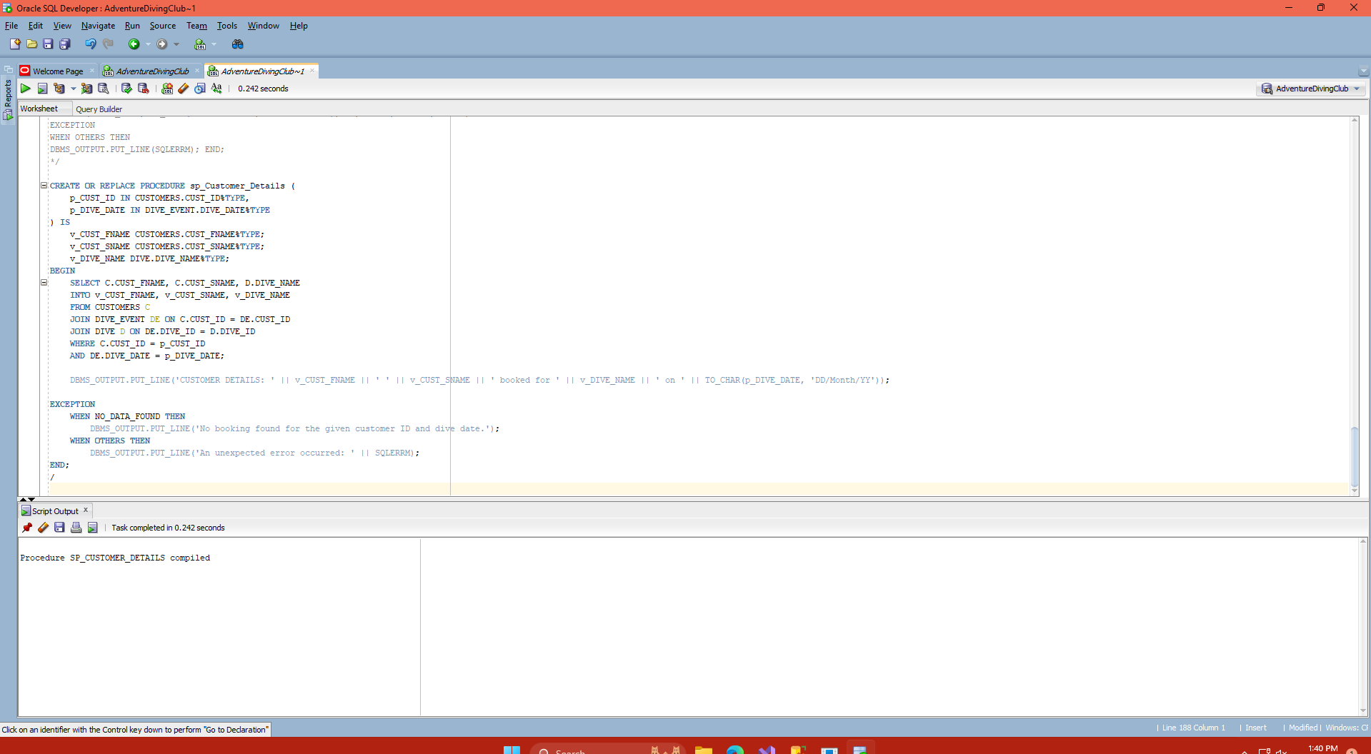

(alex, 2021)

**QUESTION 9**

BEGIN

INSERT INTO DIVE_EVENT (DIVE_EVENT_ID, DIVE_DATE, DIVE_PARTICIPANTS, INS_ID, CUST_ID, DIVE_ID)

VALUES ('test_001', TO_DATE('25-Jun-2024', 'DD-Mon-YYYY'), 0, '103', 'C115', '558');

EXCEPTION

WHEN OTHERS THEN

DBMS_OUTPUT.PUT_LINE(SQLERRM); END;

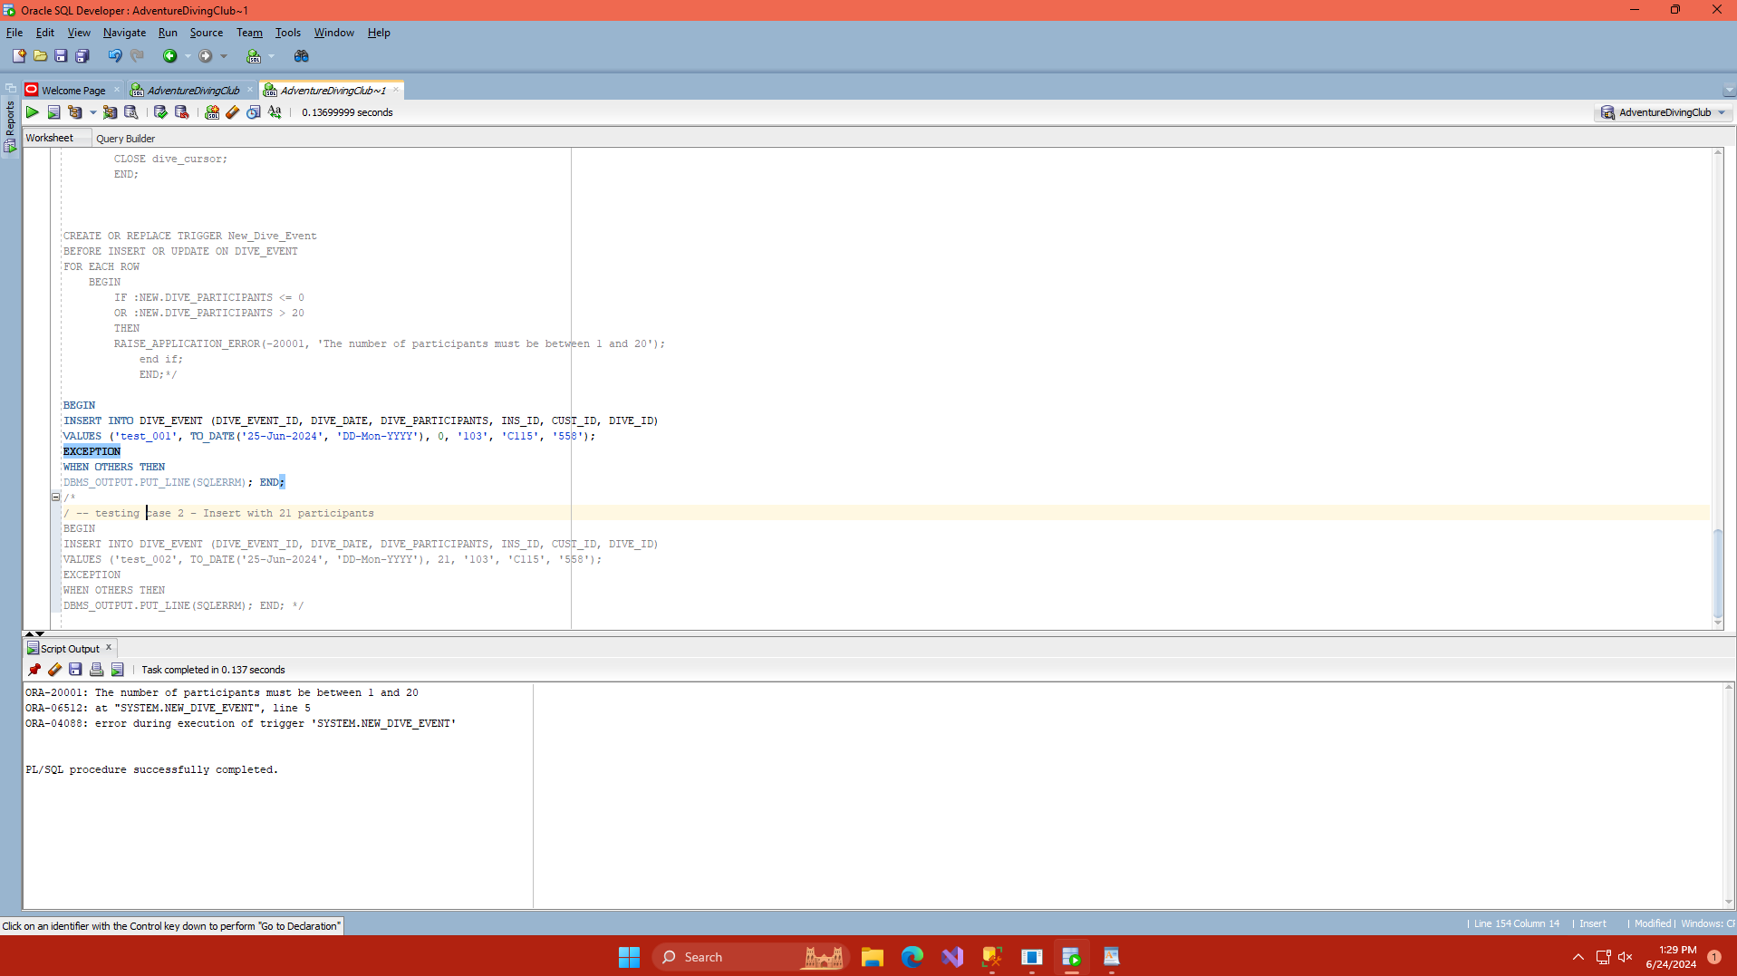

/ -- testing case 2 - Insert with 21 participants

BEGIN

INSERT INTO DIVE_EVENT (DIVE_EVENT_ID, DIVE_DATE, DIVE_PARTICIPANTS, INS_ID, CUST_ID, DIVE_ID)

VALUES ('test_002', TO_DATE('25-Jun-2024', 'DD-Mon-YYYY'), 21, '103', 'C115', '558');

EXCEPTION

WHEN OTHERS THEN

DBMS_OUTPUT.PUT_LINE(SQLERRM); END;

(LinkedIn Learning, 2022)

DECLARE

v_revenue NUMBER;

BEGIN

v_revenue := get_dive_event_revenue('de_101');

IF v_revenue IS NOT NULL THEN

DBMS_OUTPUT.PUT_LINE('Total Revenue for the dive event: ' || v_revenue);

END IF;

EXCEPTION

WHEN OTHERS THEN

DBMS_OUTPUT.PUT_LINE('An unexpected error occurred while executing the function: ' || SQLERRM);

END;

QUESTION 11: MINI PRESENTATION

*Independent Institute of Education: Module Manual & Lecture Slides (2024)*

*Advanced SQL tutorial: Stored procedures + use cases* (2021) *YouTube*. Available at: https://youtu.be/NrBJmtD0kEw?si=6jkPHqSQWZJGJ2rI (Accessed: 24 June 2024).

*How to create insert trigger using SQL server* (2017) *YouTube*. Available at: https://youtu.be/KLJ29y3qqyk?si=Q99SHjPnAfSfxn4Z (Accessed: 24 June 2024).

*SQL tutorial - using functions* (2022) *YouTube*. Available at: https://youtu.be/8OCM0zL4QeI?si=_lWaUuPUuiXmYqE0 (Accessed: 24 June 2024).